Android Quiz Student Application – Reflective Development Report

Name: Abu Bakar Amjad

Student ID: CC3672431

Year: 2025/26

Course: Computer Science

Table of Contents
Name: Abu Bakar Amjad 1
Student ID: CC3672431 1
Year: 2025/26 1
Course: Computer Science 1
Introduction 2
Overview 4
Development Process 6
Use of Kotlin Data Classes and Serialization 8
User Interface Design 9
Styles, Themes and Fonts 9
Jetpack Compose 11
The importance of ViewModel 12
Flow or LiveData 13
Navigation and Back Stack Management 13
Nav Host 13
Back Stack Management 14
The use of Lazy lists vs Normal Lists 16
Error Handling 18
Extension 1 18
GitHub Commits 20
Conclusion 21
References 22

Introduction
This report describes the design and development of my Android quiz application created using Kotlin and Jetpack Compose in Android Studio. This application was developed as part of a university assignment which required the creation of an application using Android Studio following a given GitHub README file containing the required specifications. The application needed to meet the minimum requirements and Extension 1 and 2. However, extension 2 was not completed due to continuous errors and crashes in the application.
The overall aim of the application was to allow a user to select a topic between the available options. These were: Activity and Intent, Jetpack Compose, Kotlin and View model Room. After a topic being selected the user needed to complete a quiz of 10 randomly generated multiple-choice questions and receive a score. Extension 1 required the application to display all submitted answers, colour code them to show correct and incorrect answers and provide their correct answers if wrong. Finally, extension 2 required tests to be stored in a ROOM database and be able to be accessed through a “history” feature, display topic, dates and scores, include a filter option and allow the user to select one and display the submitted answers and questions, also colour coded to show right and wrong answers. Below are the screenshots giving an idea of how the outcomes for each stage should look like.
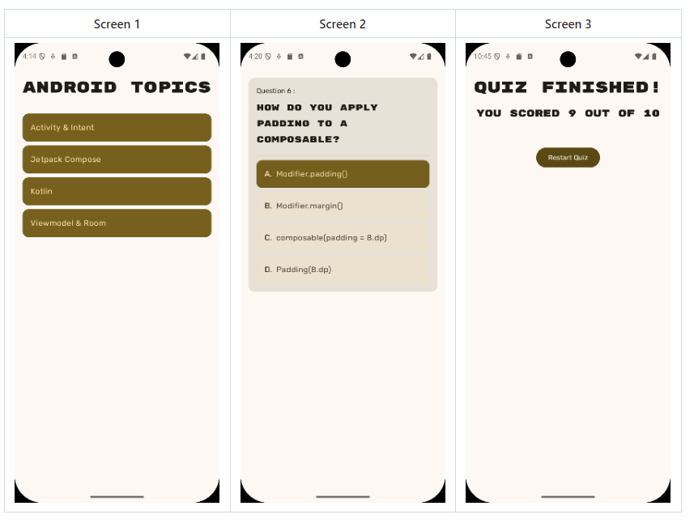
Figure 1-minimum requirements.
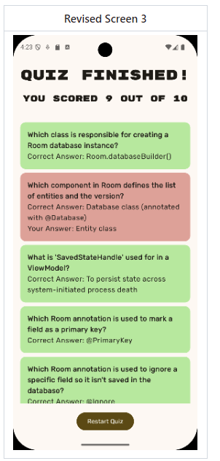
Figure 2 - Extension 1
The project was developed using Android Studio Otter 2, Kotlin, Jetpack Compose, Navigation Compose, Gson serialization and Android ViewModel architectures. Throughout the development of this application, Github was used for version control with regular commits to document the progress of the application.
This report critically reflects on the implementation phase, the Android concepts used, the development process and challenges encountered while developing the App.

Overview
The completed application consists of 3 main screens:
- Topic selection screen
- Quiz screen
- Results screen
The user firsts selects a topic of their choice from the list. Once a topic has been selected, the application will load 10 randomly generated questions regarding the topic, which are obtained from the Json files stored in the assets folder. The user will then answer each question one at a time. Once all 10 questions have been answered, the application will display a results page where the score will be displayed and there will be a button to go back to the topic selection screen. In Extension 1 the results screen will be improved to display a full breakdown of the submitted answers, including colour coded answer cards and their correct answers if required. The quiz topics supported by the application are as follow:
- Activity and Intent.
- Jetpack Compose.
- Kotlin.
- ViewModel & Room.
The project follows a simple yet organised structure using folders for:
- UI.
- ViewModel logic.
- Data.
- Model classes.
- Navigation between pages.
These separate folders allowed for easier implementation of the application and maintenance. The folders can be seen in the screenshot below.
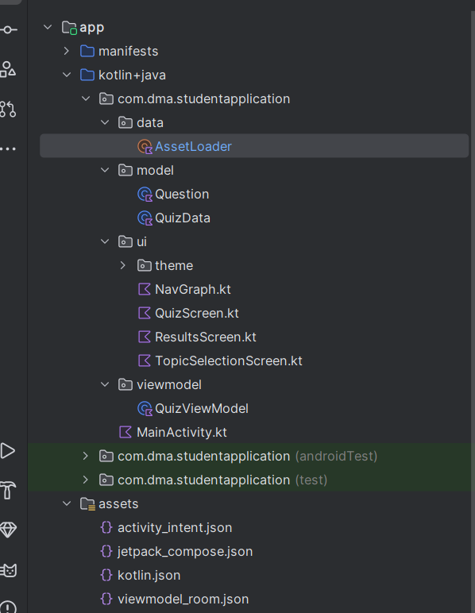
Figure 3 - Project structure.

Development Process
The first stage of the development of this application was the understanding of the requirements presented on the README file for the minimum requirements being:
- Topic selection page.
- 10 random questions for each quiz.
- One question displayed at a time.
- Results page.
- Restart functionality.
The requirement screenshots also show that the application needed to be separated into 3 different composable screens. After planning the structure of the application I began the development.
The first files created as part of my application were the model classes:
- Question.kt
- QuizData.kt
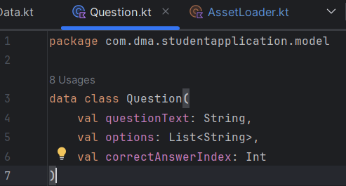
Figure 4 - Question class.
Figure 4 shows the implemented Question.kt class which created a data class for each question, storing the question itself, the options to choose from and the correct answer index that showed which option was correct.
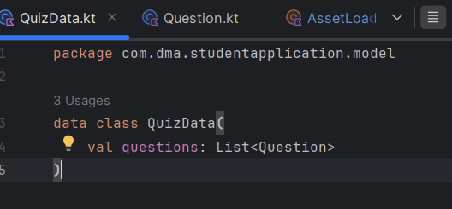
Figure 5 - QuizData class.
Figure 5 shows the QuizData class which stores a collection of questions inside the same object. This represented an entire quiz topic file to contain all the questions inside the JSON files for each topic.
This early implementation stage can be shown by my GitHub commit history as seen below.
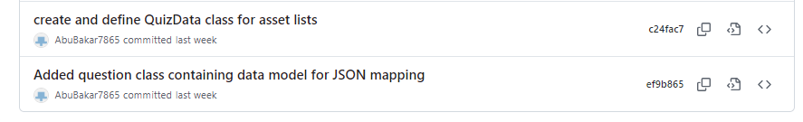

Use of Kotlin Data Classes and Serialization
One of the most important technical features in the application was serialization. This is the process of taking in a data structure, wrapping it up and transmitting it to another service for reading, which is done by converting the data object into a byte stream and saving the object to be transmitted across a network (Offley, 2010).
The quiz questions were stored inside JSON files within the assets folder. In order to convert the JSON text into Kotlin objects, for the application to be able to read them, I used the Gson library, which is used to convert a JSON string to an equivalent Kotlin object and vice versa (Torunoğlu, 2024). This was done inside the AssetLoader.
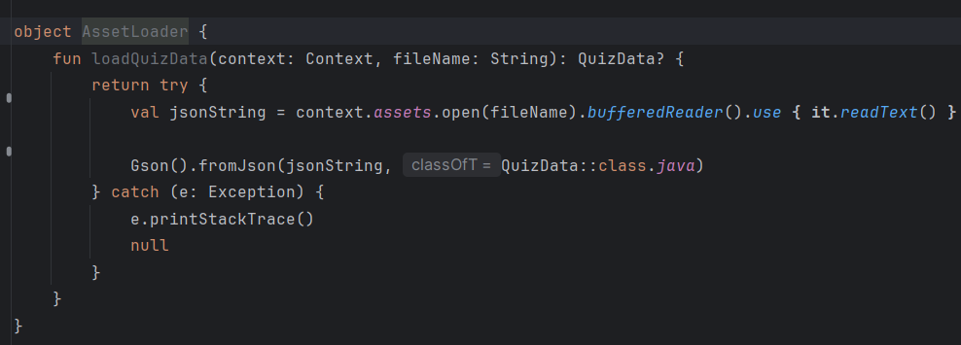
Figure 6 - AssetLoader object.
The AssetLoader object handled the process of reading the Json files from the assets directory. This allowed the application to open and read these as text. It then used the Gson library to convert the Json text into Kotlin objects.
Serialization was important because it allowed quiz data to be separated from the user interface. Instead of hardcoding questions directly into the application one by one, questions could easily be modified and updated by simply editing Json files. If additional topics were to be required in the future they could just simply be added to the assets directory without needing major changes to the UI, making the app more scalable, maintainable and flexible.
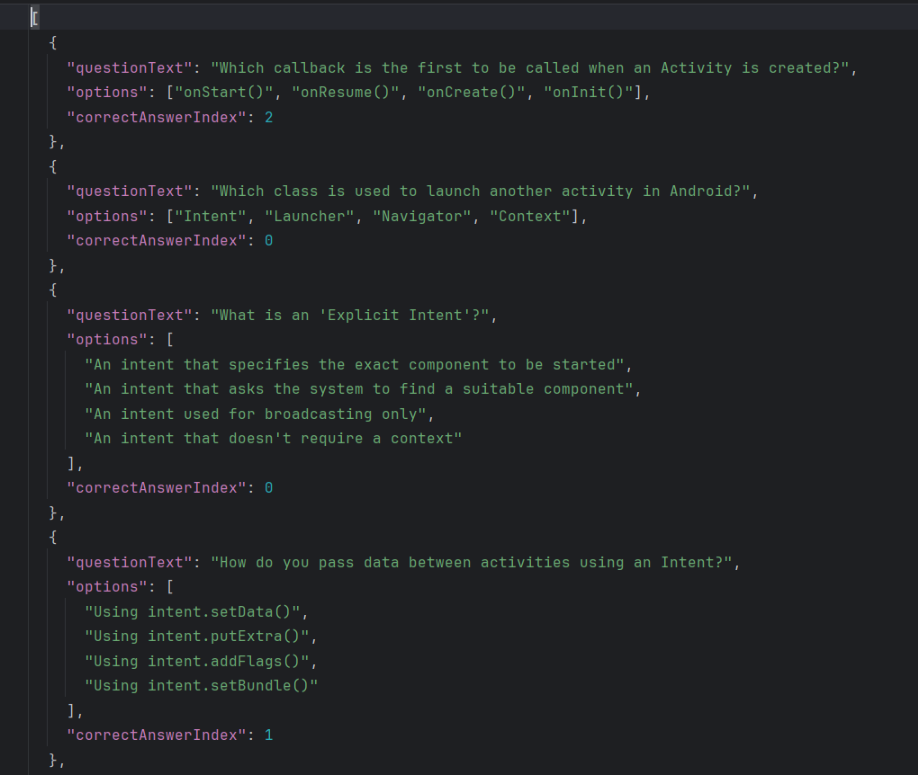
Figure 7 - example of Json structured questions.

User Interface Design

Styles, Themes and Fonts
Jetpack Compose allowed me to design a modern user interface design using my own custom components. These were:
- Colours.
- Typography.
- Button styles.
- Spacing.
- Shapes.
I did this by implementing various classes for each page. An example was the TopicSelectionScreen class where I used a blue colour palette to create a clean custom appearance.
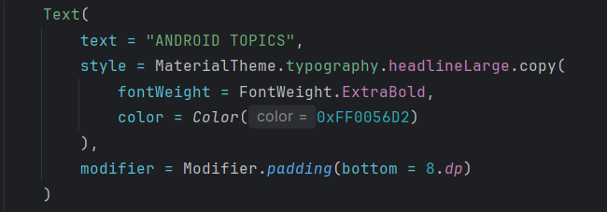
Figure 8 - title setup.
Figure 8 shows an example of the application of my own custom colours and themes applied to the tile text “Android Topics” where the colour used is a dark blue, the font is extra bold and the sizing has been made large so that it can be displayed clearly.
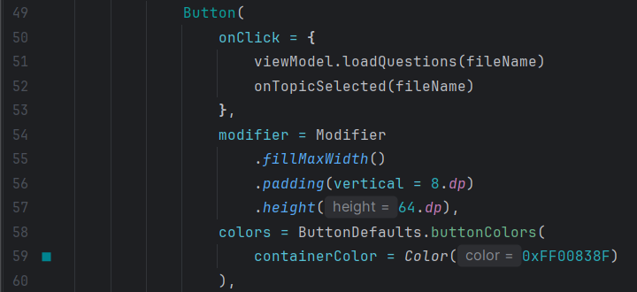
Figure 9 - Topicselectionscreen button.
Figure 9 again shows another example of the application of custom themes and colours to the TopicSelectionScreen. I chose to make the buttons fill the width of the screen and also be relatively large for easier interaction and also maintained a custom blue colour theme to these as well.
I also attempted to follow Material Design principles. This is a framework created by Google to simplify the creation of intuitive, consistent and accessible digital designs that need to be human-centred (Srivastava, 2024). I did this by maintaining consistent spacing, alignment and typography throughout the whole application and making spacings and buttons larger and easier to see.

Jetpack Compose
The whole user interface was built using Jetpack Compose instead of XML layouts. Jetpack Compose allows simpler UI development by allowing the interface to be created directly in Kotlin using composable functions offering a more reactive approach, whereas XML requires layouts to be created and then turned into actual UI components using Java or Kotlin (Komilov, 2024).
Examples of composable functions in my application include:
- TopicSelectionScreen
- QuizScreen
- ResultsScreen
- ResultCard
One major advantage of using Compose was state-driven UI updates. This meant that when the ViewModel state changed the interface updated automatically, as can be seen in the code below.
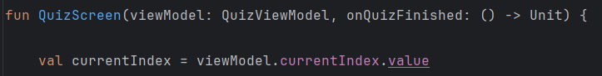
Figure 10-QuizScreen index for question.
Figure 10 shows the first lines of code from the QuizScreen, where, as the question index changes the displayed question updates automatically following the QuizViewModel, without requiring manual UI updates. This is because the QuizViewModel sets state driven values defined as “MutableStateOf” as can be seen in figure 11 below.
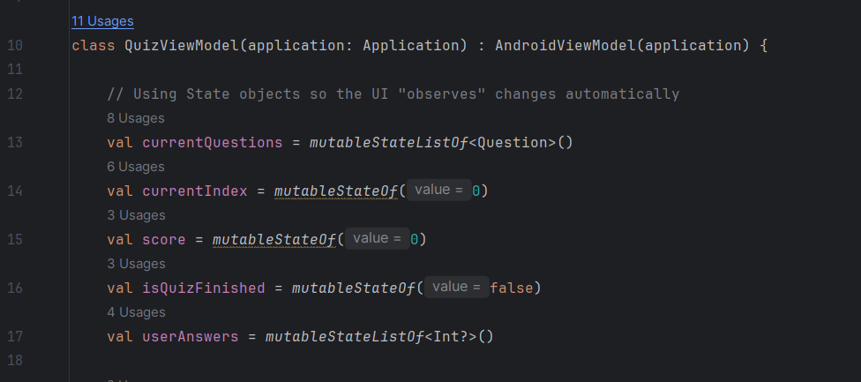
Figure 11 - state objects used in ViewModel.
The use of Compose allowed for improved code organisation by allowing each screen to be separated into reusable functions. A great example of this was the ResultCard composable which was useful in allowing each result to be reused inside the LazyColumn.
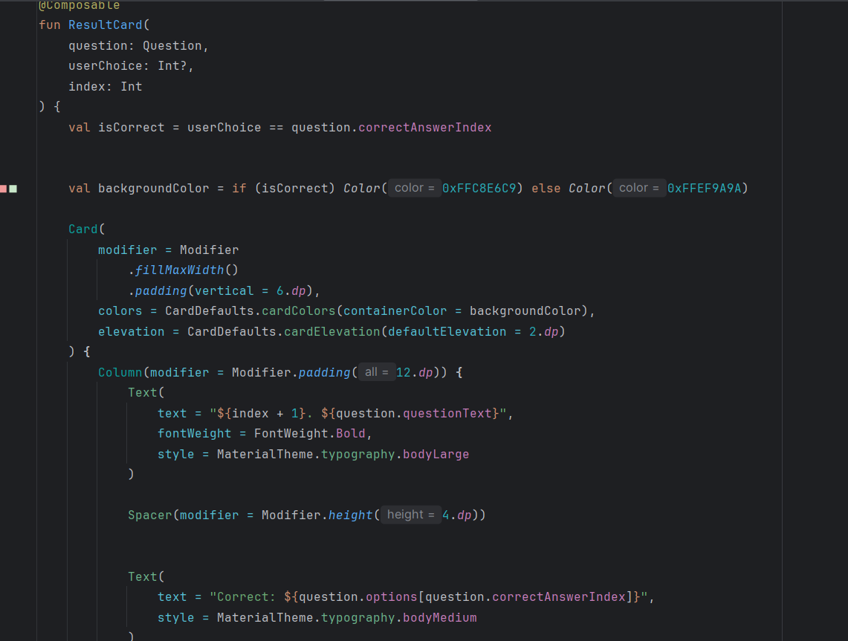
Figure 12 - ResultCard composable.

The importance of ViewModel
The QuizViewModel was one of the most important components in the application as it stored:
- Current quiz question
- Question index
- User score
- Completion state
- User answers
Using ViewModel improved the architecture because, without a ViewModel, the state of the UI would reset whenever the device rotated or recomposed. This is reflected in the following GitHub commit demonstrating an understanding of Android lifecycle management:
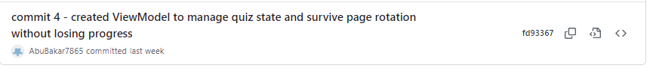
Figure 13-commit from GitHub.
As can be seen from figure 11 earlier, the ViewModel used mutable state objects. These allowed Compose to observe the changes to these objects automatically and apply them to recompose the UI accordingly.
The ViewModel also handled the answer submission logic, which made the UI screens easier to maintain and navigate and ensured that a score value was added if the current question is answered correctly and we can see this function in figure 14 below.
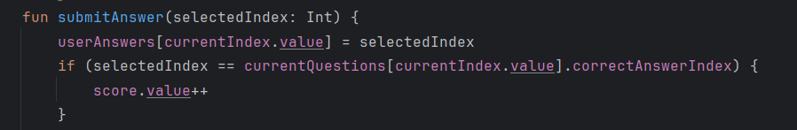
Figure 14 - answer submission logic

Flow or LiveData
Other alternatives to Jetpack Compose would have been Flow or LiveData. These are both Android technologies that allow the management of data and communication between different components of an application, such as UI and data sources. Livedata holds and observes data changes and Flow provides a more flexible and composable way to work with asynchronous data, which is data that is sent at any time without being in sync with the receiver (Aung, 2023). However, in the case of the development of this application these 2 were not required as compose mutable state already provided reactive UI updates. Whenever, the state changed inside the ViewModel, the composable automatically updated.

Navigation and Back Stack Management

Nav Host
Navigation between screens was implemented using Navigation Compose. The QuizNavhost file defined the application routes which controlled and facilitated navigation between:
- Topics
- Quiz_screen
- Results
This can be seen in the following screenshot from the code contained in NavGraph, where the NavHost implements a starting screen as the TopicSelection screen and once a topic has been selected it moves onto the next screen which is the QuizScreen where the questions will be displayed.
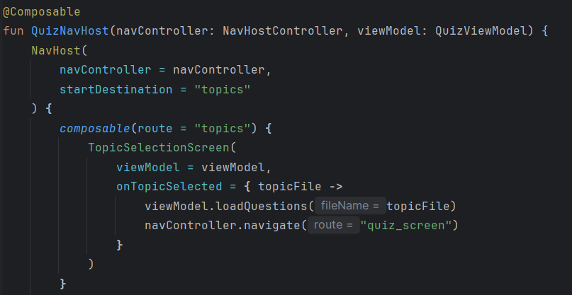
Figure 15 – NavHost.
The use of a navigation system allowed for a smoother user experience, allowing them to switch between screens easily. This stage of implementation is reflected in the commit history on Github as shown below.
Figure 16 - commit history of navigation controller.
Figure 17 - commit of finalising Navgraph.

Back Stack Management
Back stack management was important to control how a user moved between screens. When restarting the quiz I used the following command:
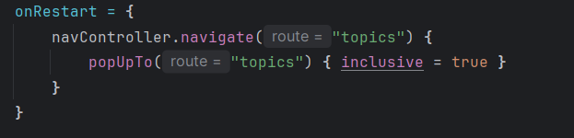
Figure 18 - restart button code.
This ensured that when the user pressed the restart button he was brought back to the topic selection screen, and cleared previous quiz screens from the navigation stack. Without this the user could press the back button and ended up inside an old completed quiz. This code ensures the correct management of the back stack and prevented any navigation bugs, also improving usability and demonstrated the understanding of Android navigation lifecycle behaviour. The correct use of the navigation compose and the single question layout is clearly demonstrated in the screenshot below displaying a quiz screen with a question and multiple choice to be picked by the user.
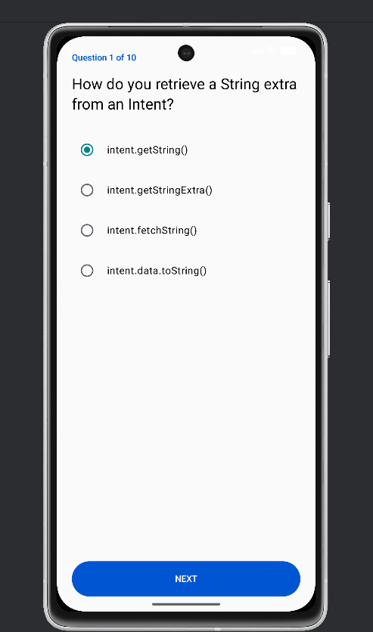
Figure 19 - quiz screen demonstrating Nav Compose.

The use of Lazy lists vs Normal Lists
One important concept used in this project was the implementation of a LazyColumn, Lazy lists are useful when a scrollable list needs to be displayed and they also ensure that memory is used efficiently by only placing the items visible on screen inside the memory and once the user scrolls away they are recycled. Lazy lists also make the scrolling buttery smooth even with complex items, and allow the app to handle large datasets without crashing or grinding to a halt (Bankole, 2023). These features make a lazy list a lot more efficient for extension 1 where a scrollable vertical list needs to be displayed with result cards containing the answer selected and corrections if needed. This can be seen below.
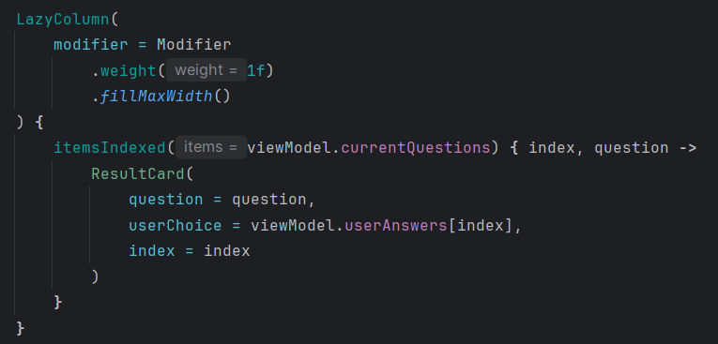
Figure 20 - use of LazyColumn
The screenshot in figure 20 shows the use of a LazyColumn. This is because LazyColumns are used for vertical lists, whereas if a horizontally orientated scroll was required I would’ve used a LazyRow. Another thing we can see from the screenshot is the effective use of the ResultCard composable that would display the selected answer, if the answer was correct, if incorrect it will display the correct option and also colour code the cards to display correct answers in a green colour and incorrect answers in red.
A normal column, opposed to a LazyColumn, would load every component immediately even if they weren’t showing yet, this would be acceptable for a small list however it could cause crashes or loading issues for a larger dataset. A standard column was used earlier for smaller fixed layouts that didn’t require scrolling such as the TopicSelectionScreen and the QuizScreen. This is because these screens contained a limited number of components.
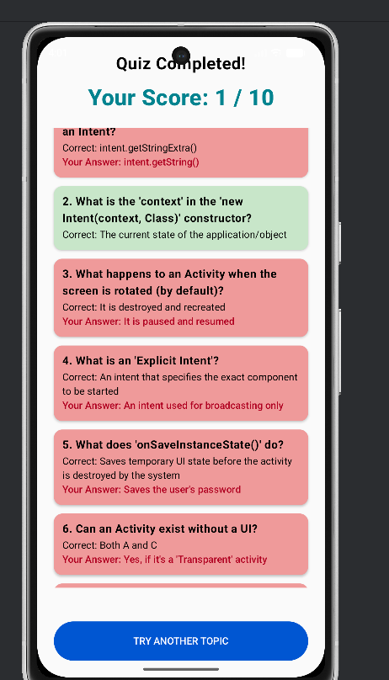
Figure 21 - LazyColumn implemented in result screen.
Figure 21 shows the successful implementation of a LazyColumn inside the result screen displaying the score and the colour coded result cards. We can also see it is a scrollable as the first question has been scrolled almost completely and there are 4 more result cards below number 6.

Error Handling
During runtime, several issues were encountered. One of which was the continuous crashing of the app, which is why I implemented a catch exception to display what exactly caused the error.
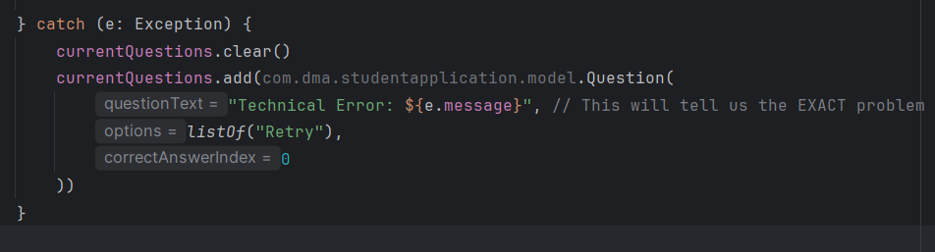
Figure 22 - try-catch exception
This is shown in figure 22 and was implemented inside the QuizViewmodel. After implementing the try-catch exeption I ran the application again and the error message showed that there was a syntax error inside the JSON files. After fixing the format of the questions, which was done by adding [] at the start and end of each file the app was finally running again and I could continue my implementation.

Extension 1
The requirements for extension 1 were to display:
- A score (implemented already inside minimum requirement)
- All answered questions
- Colour coded results (red-wrong, green-correct)
- Correct answers displayed under incorrect responses.
To do this, I made use of the ResultCard composable, however before doing so I implemented an answer tracking list shown below.
Figure 23 - tracking user answers list.
The list stored selected answer throughout the answer to be able to use these for the results screen.
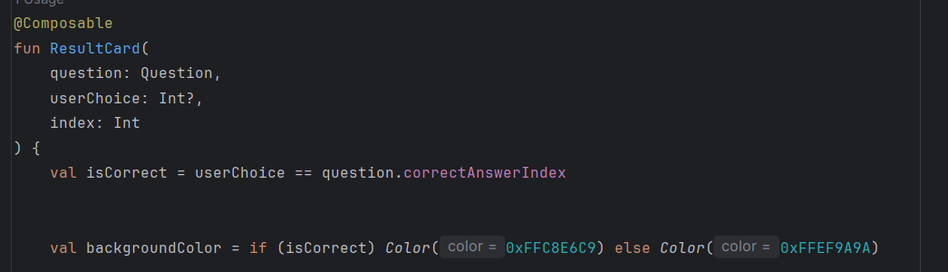
Figure 24 - implemented result card
Next, I implemented the result card shown in figure 24. Each result card first checked whether the user matched the correct answer according to its index, then the background colour changes according to whether the answer is correct or incorrect.
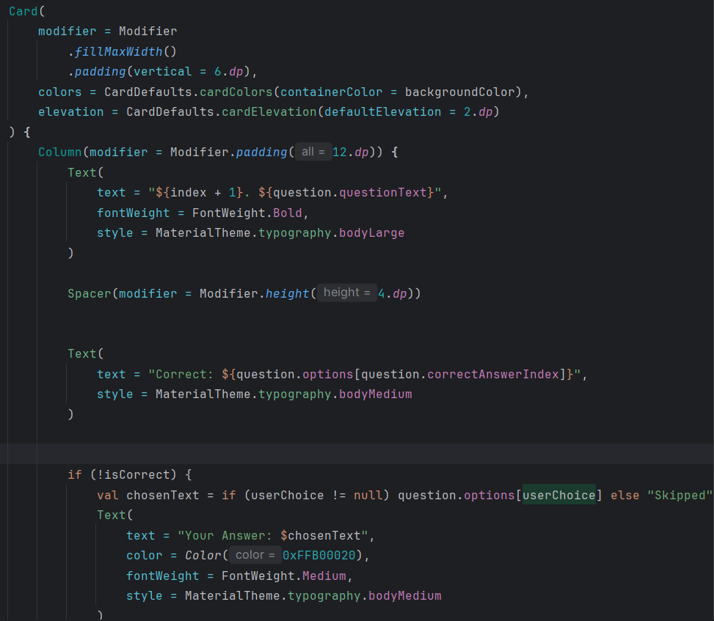
Figure 25 - result card configuration
The screenshot above shows how each card is structured. Firstly it creates a card composable that fills the whole screen’s width, adds spacing above and below each card, sets the background colour of each card using backgroundColor created earlier, displays the question text and the number index while also making it bold to increase visibility, then it displays the correct answer by accessing the list of options, the correct answer index and retrieving the correct choice, next it shows the user selected answer and finally it changes colour between red and green depending on correctness.

GitHub Commits
GitHub was used for version control throughout the whole process, here I committed changes and implementations regularly with descriptive messages. Some of the Commits history is shown below:
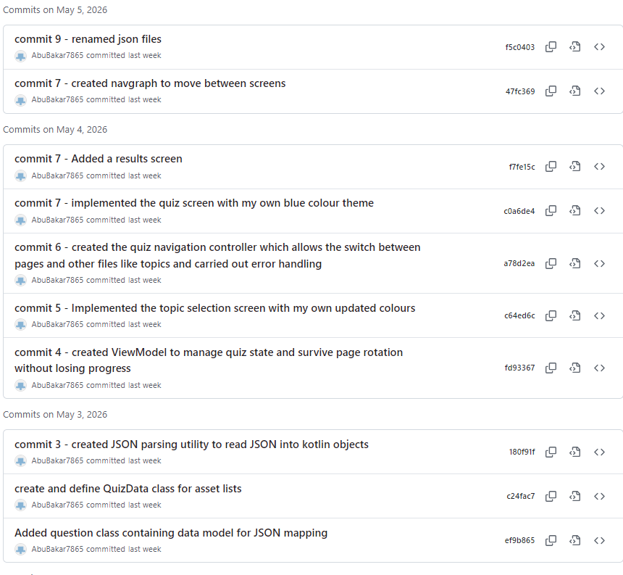
Figure 26 - commit history example
This ensured that I had backup protection in case something went wrong I could continue development from my last commit. This was useful while I tried implementing Extension 2. This is because while trying to add the ROOM database for the requirements of extension 2,I had to apply some changes to the gradle files and the gradle versions. However, these changes caused the application to crash completely, and I got a warning message telling me that the gradle files were now corrupted and couldn’t be used. After several attempts at resetting the files, clearing cache, re-syncing the gradle files to the application and more, I was not able to continue the extension 2, therefore I had to go back to the latest working version and this was done by deleting the whole project from my system and re-cloning the application up until extension 1.
The continuous upload of various commits describing my progress also ensured I was following good software engineering practice.

Conclusion
In conclusion, this project involved developing a quiz-based Android application using Kotlin and Jetpack Compose inside Android Studio. My final application successfully implemented:
- A topic selection screen
- Single-question display and quiz navigation
- A score calculation
- Resultcards providing feedback
- Colour-coded answer review
- A restart functionality.
The implementation of these, also demonstrated the use and understanding of Android development concepts such as:
- ViewModel architecture
- Navigation Compose
- Back stack management
- Serialization
- Lazy lists
- Design styling such as styles, themes and fonts.
Although, I was not able to implement a ROOM database, the project significantly improved my Android development skills and understanding of various concepts used to make my application better. The use of GitHub also ensured a structured and professional workflow, while also allowing me to save my progress without the need of starting over once the app crashed.
Overall, the application fulfilled the minimum requirements and completed the requirements for Extension 1 successfully, while following good software engineering practice and guidelines set in the README file.

References
Aung, K.S. (2023) Flow vs LiveData in Android Architecture Components. Medium. Available at: Medium (Accessed: 13 May 2026).
Bankole, A. (2023) Jetpack Compose Lazy Lists: Understanding the Basics and Building Complex Scrollable Screens. Available at: Android Developers Medium Publication (Accessed: 13 May 2026).
Komilov, Y. (2024) Jetpack Compose vs XML in Android: A Detailed Comparison. Available at: Medium (Accessed: 13 May 2026).
Offley, G. (2010) What is Serialization? freeCodeCamp. Available at: freeCodeCamp (Accessed: 13 May 2026).
Srivastava, S. (2024) Material Design Principles: 20 Key Takeaways for UI/UX Designers. Available at: Interaction Design Foundation (Accessed: 13 May 2026).
Torunoğlu, Z. (2024) Gson on Android. Available at: Medium (Accessed: 13 May 2026).

